# RPI-1

Pantalla (LCD) (VERDE)

<https://wiki.seeedstudio.com/Grove-LCD_RGB_Backlight/>

NFC (AZUL)

<https://raspberrypi-espana.es/rfid-frambuesa-pi/>

Cebador (ROJO)

LED ( AMARILLO)

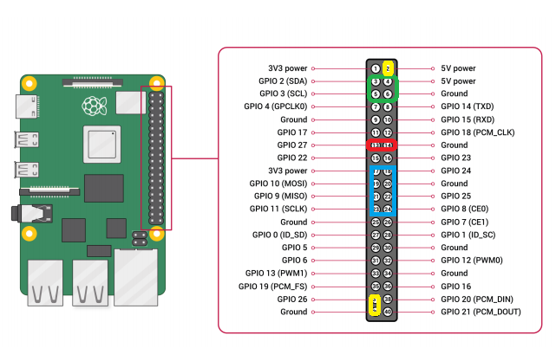

# RPI-2

Temperatura

<https://wiki.seeedstudio.com/Grove-TemperatureAndHumidity_Sensor/>

# RPI-3

Acelerómetro

<https://www.stuffaboutcode.com/2014/06/raspberry-pi-adxl345-accelerometer.html>

Ventilador

<https://www.switchdoc.com/2016/02/tutorial-grove-connector-project-examples-for-raspberry-pi-arduino/>